Laboratory 4 Assignment

“TIJUANA TAXI LOCATION PROBLEM”

( ACOUSTIC DIRECTION FINDING )

Lab Dates: Weeks 7 and 8

Lab Report Due Date: At the beginning of the lab on March 2nd for Tuesday session.
Bring to Lab:
- Earphones for PC earphone port, or powered speakers for PC line-out port.
- Ruler or tape measure to measure microphone spacing and sound source distance.

Lab Theme Music: Use Windows Media Player to listen to “Lab4ThemeSong.wav”
(Herb Alpert and the Tijuana Brass) obtained from course lab web page.

1. Introduction

A taxi company in Tijuana, Mexico, wants to keep track of the locations of its taxis within the city, but does not have the financial resources to install expensive satellite-derived GPS (Ground Positioning System) equipment. An inexpensive acoustic direction finding (DF) system has been proposed as an alternative to GPS that exploits the unique sound of the quaint taxi air horns, as heard in the lab theme music. Dual-microphone assemblies, similar to that which you will be using in the lab, would be placed on the top of buildings dispersed throughout the city. Each microphone assembly is able to calculate and to report a bearing (also known as direction of arrival [DOA]) to each horn heard within its acoustic range. Through a triangulation process, which you will develop in this lab, the location of a horn (and therefore the taxi to which it is attached) can be established. This lab will validate the feasibility of the proposed acoustic DF approach.

You will have the opportunity in this lab to experiment with three acoustic data sources in order to develop and to test the bearing estimation and location triangulation techniques. The first data set with which you will work is a digital recording of a Tijuana taxi horn toot received at a single dual-microphone assembly, for which the time of arrival of the toot at each microphone is different due to the path length differences to each microphone from the source of the toot. This time-difference-of-arrival (TDOA) is known in advance for this data set. The TDOA will be estimated, by developing Matlab code based on cross-correlation (a variant of the convolution operation), and compared to the known TDOA. The TDOA is then simply converted to a bearing.

The second data set is a digital recording of thunder as received simultaneously at two sites, each site having a dual-microphone acoustic sensor assembly. A bearing to the source of the thunder can be determined from each site using TDOA estimates and, via geometric triangulation techniques, you can pinpoint the source of the thunder (the lightning strike location).

The third acoustic data set will be acquired live by you during the lab. You will be provided a horn to use as an acoustic source and you will use the dual-microphone assembly of Lab 1 to record the horn toots as received by the assembly at two locations on your lab bench. Using the same TDOA, bearing, and triangulation techniques developed for the taxi horn and thunder data sets, you will then determine the location of the horn from the live recorded audio signals.

2. Objectives

2.1 Develop Matlab correlation and triangulation code for direction finding/localization.
2.2 Locate lightning strike from pre-recorded thunder data of a two-position DF acoustic system.
2.3 Acquire live acoustic data (horn toot) and locate the position of the horn relative to the
location of your lab station.

3. Background

By using sensors distributed in space, it is possible to locate an emission source by operating on the signal, propagating from the source, as sensed at each sensor location. Typical signals that propagate in space include electromagnetic signals, audio signals in air, ultrasonic acoustical signals, under water acoustic signals, and seismic signals [e.g., earthquakes] through the ground. For this lab assignment, you will utilize relative time delay (TDOA) estimation and geometric triangulation to localize acoustic signal sources relative to the location of microphone sensors picking up the propagating acoustic wave. The techniques you will employ in this lab are widely used to perform propagating signal source localization.
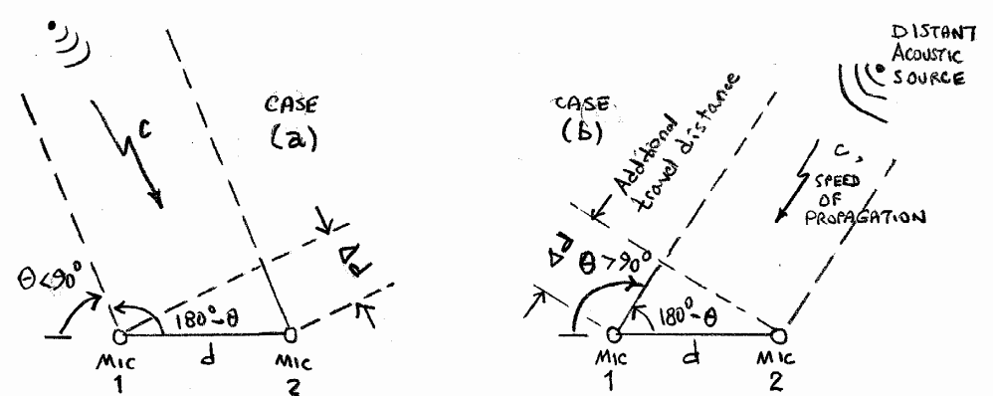

Figure 1. Propagating signal reception geometry under the far-field assumption (distant acoustic source). In case (a), the bearing (arrival angle) is less than 90 degrees and it takes longer for the signal to reach microphone 2 than to reach microphone 1. In case (b), the bearing is greater than 90 degrees and it takes longer for the signal to reach microphone 1 than to reach microphone 2.

3.1 Bearing Determination. Consider in Figure 1 an emitting acoustic source that creates an acoustic signal picked up by a pair of omni-directional microphones spaced d units (cm, in, etc.) apart. We will assume a nominal uniform velocity of propagation of c=331 meters/sec =13031 in/sec for sound in air at sea level. The difference in the propagation paths (ranges) to each microphone sensor is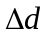, and the difference in arrival time  (TDOA) is then expressed simply as 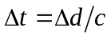. The parallel paths shown from the source to each microphone is based on the assumption of the far-field approximation, in which the microphone separation d is much smaller than the distance to the acoustic source. Each microphone will then share a common arrival angle, based on the reference convention shown in Figure 1, which is also known as the source bearing. For this lab, the microphone separation is about 10 inches and the range to the acoustic source should be at least 20 feet to roughly satisfy the far-field approximation. Based on the right-angle geometry shown in Figure 1, the difference in propagation range is 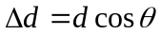, which means the TDOA is expressed as 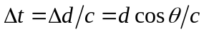. By convention, the sign of for case (a) in Figure 1 is considered to be positive (bearing is less than 90º), whereas for case (b) it is considered to be negative (bearing is more than 90º, making the cosine negative in value). In practice, once we estimate the relative arrival time difference between the spaced microphones, the bearing estimate would be calculated simply as 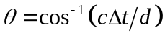 , expressed either in radians or in degrees.

3.2 TDOA Estimation Via Cross Correlation. We need a means to estimate the TDOA from the two received signals of the dual microphone assembly. We shall use the cross correlation function 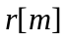 for this purpose, defined for integer index interval 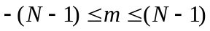as
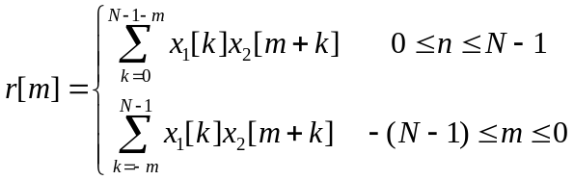
in which is the assumed time duration of each signal, 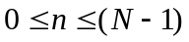, in samples. The actual signal duration in seconds would be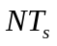, for which 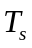is the sampling interval in seconds. The cross correlation has the property that a plot of it as a function of reaches it maximum at the integer indexnearest to the actual time delay, such that 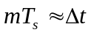. For case (a) in Figure 1, the value nearest the maximum will be positive, indicating that the received signal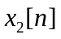in channel 2 lags the received signal 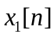 in channel 1 by approximatelysamples. For case (b) in Figure 1, the value nearest the maximum will be negative, indicating that the received signal in channel 1 lags the received signal in channel 2 by approximately 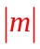 samples. Thus, the method of estimating the TDOA is to search for the peak in the calculated cross correlation and to note the sample index (positive or negative) associated with the peak, and then use 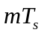as the estimate of .

In order to actually compute the cross correlation, it will now be shown that the cross correlation is actually a special case of convolution, for which we have available Matlab functions. Consider the case in which both the input signal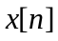 and impulse response 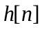 are each of -sample duration over the interval . The discrete-time convolution output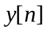, which has a 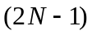-sample duration over the interval 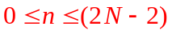, is defined as (see text Chapter 2 from ECE351):
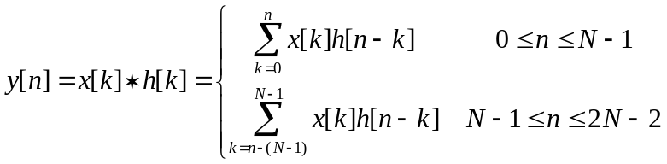
Next, define 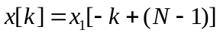, that is, as a time reversal (“flip”) of the channel 1 signal, and define 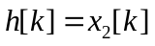, that is, let the channel 2 signal be associated with the role of the impulse response. The convolution equation then takes the form:
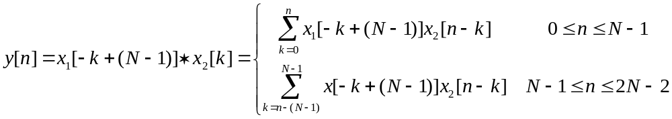
Let us now make a change of discrete index variables,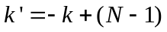, to yield:
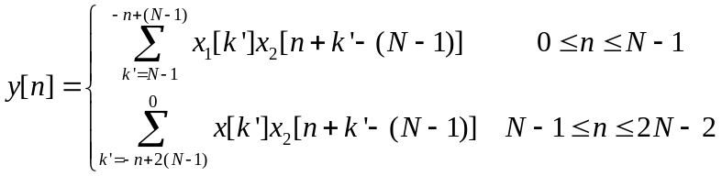
Finally, define the discrete lag (time delay) index 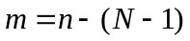, so that 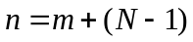. The indexing range for variables and will then be and 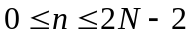, and the final form of the convolution expression becomes:
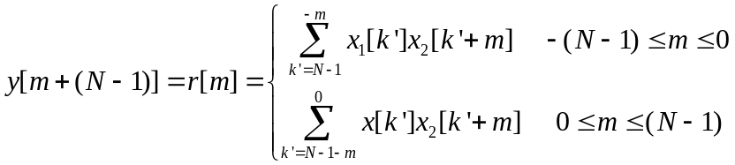
which is identical to the definition of the cross correlation! Let’s summarize: the cross correlation is computed by (1) time-reversing the channel 1 signal, (2) convolving the time-reversed channel 1 signal with the channel 2 signal, and (3) interpreting the 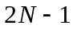 convolution output values as the cross correlation function over the index range .

In most applications, the differential time delay of a propagating signal arriving at two sensors is rarely an exact integer multiple of the sampling interval 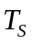. Computing the cross correlation and looking for the peak will resolve the time delay only to a precision of seconds (one sample resolution). To achieve sub-sample resolution of the time delay estimate, a sample rate interpolation scheme is required. The reference cited in section 4.0 provides such a scheme. It interpolates the cross-correlation sampling interval by a factor of M (typically 2, 4, or 8), yielding time delay estimates to a precision of 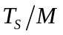 seconds. You are not required to use this cited reference for your lab project, but if you do option it, the higher precision time delay estimate may improve your location accuracy somewhat. An accompanying Matlab function related to this article has been posted on the lab web page (the file name is interp_cross_corr_env.m ).

3.3 Triangulation for Location. By using a pair of widely separated dual-microphone assemblies along a known baseline spacing, it is possible to generate two bearing estimates from the site of each microphone assembly and, through a triangulation process, to determine the location of the source. Consider in Figure 2 three triangulation scenarios in which microphone assembly pairs are placed at locations A and B with spacing units (km, m, in, ft, cm, etc.) apart (in which 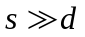, and is the local microphone pair spacing). We assume we either know or have measured the distance . After an acoustical signal event, each site reports a bearing estimate to the source of the acoustical event; these bearings are designated as 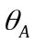 and 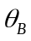 in Figure 2 using the angular reference convention of Figure 1. A plot of range lines and along the two bearings from the center of each sensor pair leads to an intersection point that represents the location of the source.

There are three possible scenarios to be considered, as shown in Figure 2. In scenario 1, both bearing angles are greater than 90º, which means the channel 1 signal lags the channel 2 signal at both A and B sites (the cross correlation peak will be a negative lag index for both sites). In scenario 2, the bearing at position A is greater than 90º and the bearing at position B is less than 90º. This means channel 1 lags channel 2 at position A, but channel 2 lags channel 1 at position B (the cross correlation peak index will be negative for position A and positive for position B). In scenario 3, both bearing angles are less than 90º, which means channel 2 lags channel 1 at both A and B sites (the cross correlation peak index will be positive for both positions).

Using (1) trigonometric identities in the Appendix (section 9.0), (2) the baseline distance , and (3) the two bearing estimates and , the source location may be found by a process called triangulation. Specifically, this means the distances and are calculated to complete the triangle. You will develop these triangulation relationships as part of the pre-lab tasking.
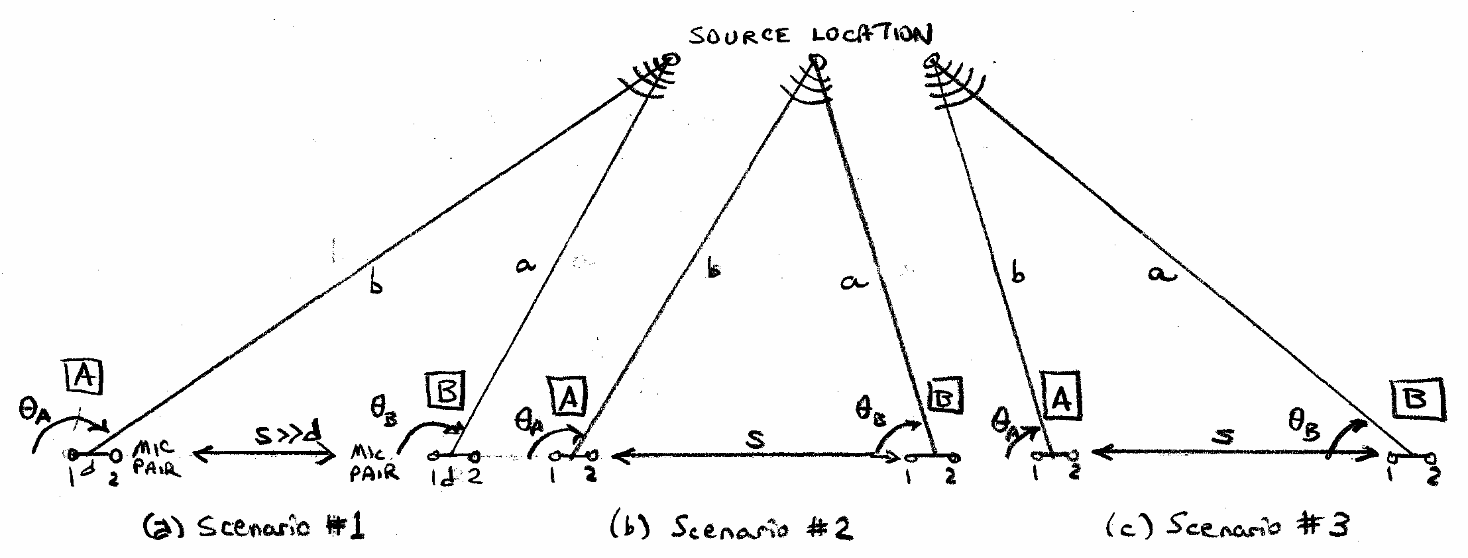

Figure 2. Three triangulation scenarios for determining acoustic source position. The dual-microphone assemblies at locations A and B are assumed to align with baseline s, with microphone channel 1 to the left and microphone channel 2 to the right at each site location A and B.

4. References

- Sound Recorder application as described in Laboratory 1 assignment.
- Discrete-time convolution, text Chapter 2; text problem 2.78 on cross correlation.
- S. L. Marple Jr., “Estimating Group Delay and Phase Delay via Discrete-Time ‘Analytic’ Cross-Correlation,” IEEE Transactions on Signal Processing, vol. 47, pp. 2604-2607, September 1999 (optional reading; PDF copy posted on course lab web page).
5. Pre-Lab Tasks ( 1 point )

Read and familiarize yourself with this entire assignment prior to start of lab!!

Submit a hard-copy of your Matlab scripts, plots, and triangulation formulas for these pre-lab tasks at the beginning of the first week of this lab, before starting the in-lab tasks, to receive 1 point of your total lab score.

5.1 Task: Create Cross Correlation Matlab Function. Create a Matlab function to compute the cross correlation using the approach described in section 3.2. The function should be defined as [r,m_peak]=crosscorr(x1,x2), in which x1 and x2 are the channel 1 and channel 2 signal column vectors, respectively, r is a column vector of the cross correlation [r(1) would correspond to the lag 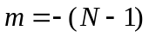 and r(2N-1) would correspond to the lag 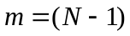], and m_peak corresponds to the lag index at the peak (maximum) value of the cross correlation. You should be able to encode the cross correlation calculation with a single line of Matlab code using the functions conv and flipud .
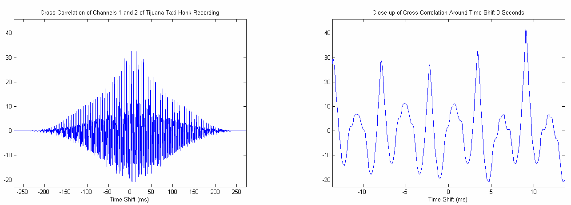

Figure 3. Examples of cross correlation plots of the Tijuana taxi horn single toot. Left plot is the full range of m lag values from the cross correlation calculation. Right plot is a close-up of the cross correlation around lag m=0. Note peak near +9 ms.

5.2 Task: Plot Taxi Horn Cross Correlation. Playback the lab theme music, available from the lab web page (Lab4ThemeSong.wav), to hear examples of the Tijuana taxi horns. Next, pick up the pre-recorded acoustic channel signal pair taxi_honk.wav, which contains an isolated audio clip of a single horn honk as picked up by a dual-microphone assembly. Import this file into Matlab using [x,fs,nbits]=wavread(‘taxi_honk.wav’). Note that the sample rate should be fs=22050 samples per seconds, the number of bits should be nbits=16, and x should have two columns [the first column x(:,1) corresponds to channel 1 and the second column x(:,2) corresponds to channel 2]. Use the cross correlation function created in Task 5.1 to compute the cross correlation between the two signal channels. Produce and save two plots of this cross correlation similar to that shown in Figure 3. One plot should plot the total range of m lag indices generated by the cross correlation function. The other plot should be a close-up of lag indices near the peak value of the cross correlation. Plot the cross correlation horizontal axis in units of milliseconds, by evaluating 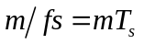to obtain the axis time units. The pre-recorded channel 2 data is known to lag the channel 1 data by 200 samples, so the cross correlation will peak for m_peak=+200, which corresponds to a time delay of 200/22050 = 9.1 ms . Use this data set to verify your implementation of the cross correlation function.

5.2 Task: Develop Triangulation Formulas. Consult the trigonometric relationships in the Appendix and develop formulas that, given the baseline s and the two bearing estimates and , compute the ranges and which effectively determine the location of the source. You will need three sets of formulas for the three scenarios shown in Figure 2. Encode these into a Matlab function for use with the Section 6 lab tasks.

6. Lab Tasks/Experiments

You will first apply the principles discussed in Section 3 to pre-recorded thunder data, which has an exact localization solution that can be checked by the lab TAs, to develop and to debug all your supporting Matlab software until your localization results match this known solution. Next, you will acquire your own live two-channel microphone data using an acoustic source (bicycle horn) provided by the lab TA. Your acquired data will then be used to determine the location of the horn relative to your lab station.

6.1 Task: Determine Lightning Strike Location from Recorded Thunderstorm Data .

A lightning locater system has been designed, based on the Figure 2 scheme, to determine the location of lightning strikes by processing the acoustic signals from the resulting thunder. The acoustic data is simultaneously acquired from two sites, A and B, separated by a baseline of s = 1 km. At each site is a dual-microphone assembly of d = 1 meter spacing between the microphones. Samples of the microphone signals during an actual lightning strike have been recorded and stored as a pair of two-channel wav files on the course lab web page [ designated as rain_A_site.wav and rain_B_site.wav ]. The sampling rate and number of bits per sample may be obtained directly from the files with the Matlab wavread function.

<> Listen to the two recorded approximately 6-second wav files using the Microsoft Media Player to hear the rolling thunder from a lightning strike. Alternately, import the files into Matlab with the wavread function and then use the sound function to playback the audio in each file as a stereo channel pair.

<> Plot each of the four channel signals in the two files and observe the time index where the thunder first arrives in the four data sets.

<> Extract approximately 1-second audio clips [suggest from sample index 22000 to sample index 42000] for all four signal channels. These clips should include a short time increment just prior to the thunder occurring and most of the first arrivals of the thunder sound (before echoes start arriving). This is a normal strategy before computing a cross correlation: eliminate distracting signal components [mostly rain in these data records] not related to the sound source to be cross correlated.

<> Use your Matlab function crosscorr and compute the cross correlation functions for the site A channel pair data clips and the site B channel pair data clips. Make and save plots of the cross correlation at each site like Figure 3: a full index range plot and a close-up index range plot that includes the peak location.

<> Observe the signs of the cross correlation peak lag indices from site A and site B. Determine which of the three scenarios in Figure 2 is appropriate for the thunder data. Convert the peak indices into TDOAs in seconds, and then compute the bearings as described in Section 3.1

<> From the estimated bearings of the previous step and the appropriate trigonometric relationships determined in the pre-lab effort for the selected scenario, determine the lightning strike location by estimating ranges and in kilometers. Go over these answers with your lab TA to verify that you have performed your calculations correctly and that they agree with the known solution.

6.2 Task: Determine Acoustic Sound Source Location Using Live Dual-Microphone Assembly Recordings.

With the confidence of a confirmed solution from your TA for Task 6.1, which means your procedure and software calculations are accurate, you are ready to perform the localization procedure with live data that you will acquire. Obtain from your TA the electronic assembly of Lab 1 that has the two electret microphones mounted on a piece of wood and labeled Channel 1 on one end and Channel 2 on the other end. These channel numbers should correspond to the channel number assignments (stereo) used by the computer when you plug the cord from the assembly into the Line In port on the back of a lab PC. You will also borrow a bicycle horn, to be used as an acoustic source, from your TA when you are ready. Perform the following steps for this task:

<> Using a ruler or tape measure, measure the spacing between the center points of the two microphones on the assembly; this is the value of d .

<> Obtain some masking tape from your TA and mark two X locations about 5 to 6 feet apart on your workbench. Your microphone assembly must be able to reach both locations while plugged into the lab computer Line In port. These will be designated as the A and B measurement sites for this experiment, similar to the A and B data collection sites in the lightning location scenario. Using a tape measure, accurately measure the distance between the centers of the taped marks; this will be the value of s.

<> Center the dual microphone board over one of the taped Xs, noting that the orientation for channels 1 and 2 should align along the baseline between the taped Xs as depicted in Figure 2.

<> Validate that the channel 1 and 2 markings on the board are correct. Make a recording while tapping with your finger on the channel 1 microphone. Import the recording into Matlab with wavread and plot both the channel 1 and channel 2 signals as designated by Sound Recorder. The tapping should only be observed in the channel 1 plot if the board markings are correct.

<> Have your lab partner, with the acoustic source (horn) borrowed from the lab TA, move to an arbitrary location about 20 feet from your microphone assembly. Borrow a tape measure from your TA, then measure and record the distance from the center of each taped X mark to the location of the horn where your partner is located. These measurements will form the ground truth that your triangulation process will estimate independently from audio recordings.

<> Use the Sound Recorder application, as you did in Lab 1, to acquire data from the two microphone channels. Be sure the sound recorder properties are pre-set to acquire audio data from the Line In port on the PC with a recording format that is (a) stereo [2 channel recording], (b) a minimum sample rate of 22050 samples per second (higher rates will make the resulting TDOA estimate from the cross correlation more precise, but the processing time will go up significantly), and (c) uses 16 bit quantization for highest amplitude fidelity, as shown in Figure 4.
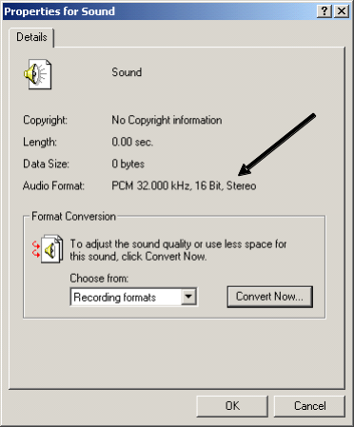

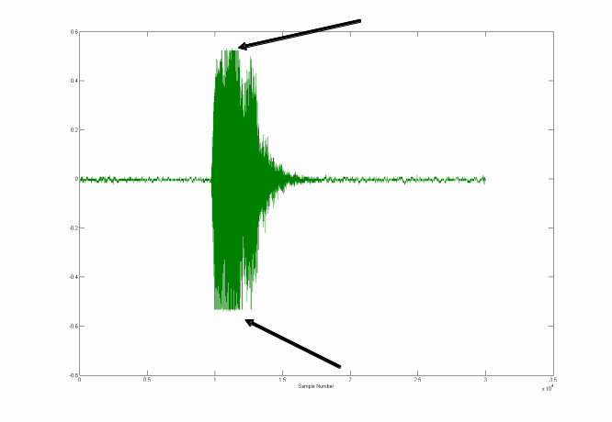
Figure 4. Ensure Sound Recorder properties are set for 2-channel recording, 16 bits, and a high sampling rate. Check acquired signals with Matlab’s WAVREAD to validate that the Audio Format selected by you (as shown in this window) was actually applied.

Figure 5. Example of a clipped signal. Both top and bottom are flat, indicating clipping. Turn the volume level control down on the Line In port (see instruction on this in Lab 1 assignment) to reduce the recording level until no clipping is observed.
You may also have to adjust the volume setting on the Line In port to prevent clipping of the acoustic source signal if it is too loud for the 16 bit quantization range. Figure 5 illustrates observable affects of clipping. Failure to prevent clipping will result in distorted and incorrect time delay estimates.

<> Start the recording, have your lab partner squeeze once on the bicycle horn in a manner that your TA will demonstrate, then stop the recording. Save the recorded data as a wav file for later processing to locate the horn source. Check the quality of your recording before moving to the next step to ensure that the two channels have a high recorded amplitude range without clipping, the sample rate is correct, the bit quantization is correct, and both channels (stereo) are recorded.

<> Move the microphone pair assembly to the other X position with the channel 1 and 2 alignment as depicted in Figure 2, and have your partner [without moving] squeeze the horn again while you record the pair of sound channels at the second site. Again, ensure the quality of data recording before leaving the lab..

<> Follow the steps as you performed with the lightning location task to determine the location of the horn toot. Clip out a portion of the recorded data record from each microphone channel pair that starts about 100ms before the horn toot arrives and ends about 100 ms after the toot ends. Find the peaks of the cross-correlation of these windowed data clips to obtain the TDOAs at each site, convert the TDOAs into bearings at each site, and then apply triangulation to determine the ranges from each site X to the horn. Compare the estimated location ranges with the actual range measurements you made with the tape measure.

7. Post-Lab Tasks

7.1 Task: Report Your Analysis of the Lightning Location.

Using the waveform plots, the cross-correlation plots, and the Matlab triangulation calculations, report the details of your analysis to support your conclusions as to the lightning strike location. The plots should be a part of your lab report.

7.2 Task: Report Your Analysis of the Horn Source Location from Live Acquisitions .

Incorporating the waveform plots of each channel pair from both sites A and B, the cross-correlation plots from sites A and B, and the Matlab triangulation script calculations, report the details of your analysis to support your conclusions as to the estimated location of the horn source. Compare this with the actual location measurements you made with the tape measure.

Question: Can you explain any differences between your true location ranges (made by tape measure) and your estimated ranges (made by time delay estimation with the cross correlation)? Consider effects such as: quantization of time delay resolution only to the nearest sample increment (rather than sub-sample resolution); other interfering and background sound sources in the lab; the fact that the microphones and the sound sources are not perfect point objects, but have distributed attributes; inaccuracies in spacing measurements; plus other conditions that you may have observed.

8. Lab Report

Use the lab report format our TA e-mailed to the class list.

9. Appendix

The following trigonometric formulas for plane triangles may be useful. The triangle is assumed to have sides a, b, and c, and the internal triangle angles opposite these sides are 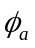, 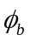, and 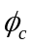 , respectively.
